**CAPSTONE_FINAL_PROJECT**

**Case Study: Climate Change Forecasting**

Below information is to sum up the activities we have performed as part of this project .

**Problem Statement**:

Aim of this project is to study the changes in Temperatures across world since 17th century till date to understand and forecast the temperature for various regions by using Deep learning .

**Tools/packages used**: NumPy, pandas, Kera’s, Tensor flow, plotly, python, scikit learn, matplotlib

**Methodologies**: Time series model, Deep learning using RNN and LSTM model.

**Data source** – We got the csv file from the Kaggle which has the temperature for various regions /countries in the world since 17th century.

**Approach**:

* Apply python libraries to import and visualize dataset
* Perform exploratory data analysis
* Visualize the data using Plotly
* Prepare the data to feed the Multivariate Time-Series Model
* Understand the theory and intuition behind Recurrent Neural Networks and LSTM
* Build and train the LSTM based time series model
* Assess and understand the performance of the model
* Assess trained model performance (U.S. Data)
* Build and train LSTM model for predicting global temperature trend (U.S. Data)
* Prepare the data before model training (U.S. Data)
* Assess model performance (Global Data)
* Build and train LSTM model for predicting global temperature trend (Global Data)

**Use/utility**:

* Model can be used to predict the temperature not only for the US region but also for other countries which has good amount of sample records at least of count more than 1500.
* The model can also be used in conjunction with the pollution data for the same countries or region to understand the correlation of the same.

Model performance snapshots:

Model performance – Global data :

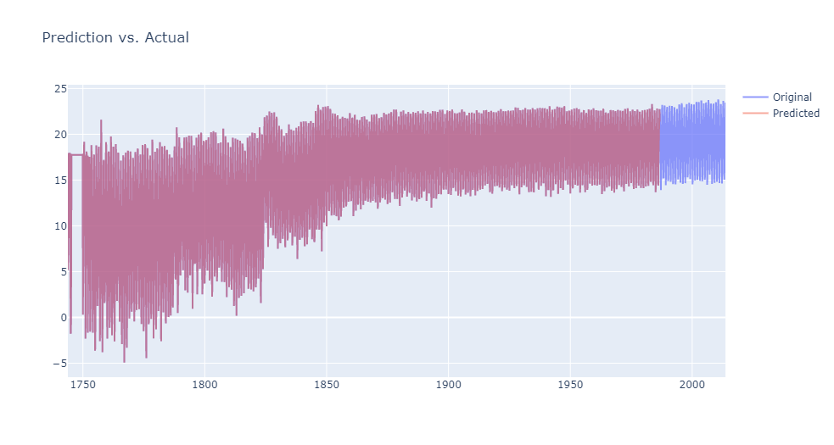

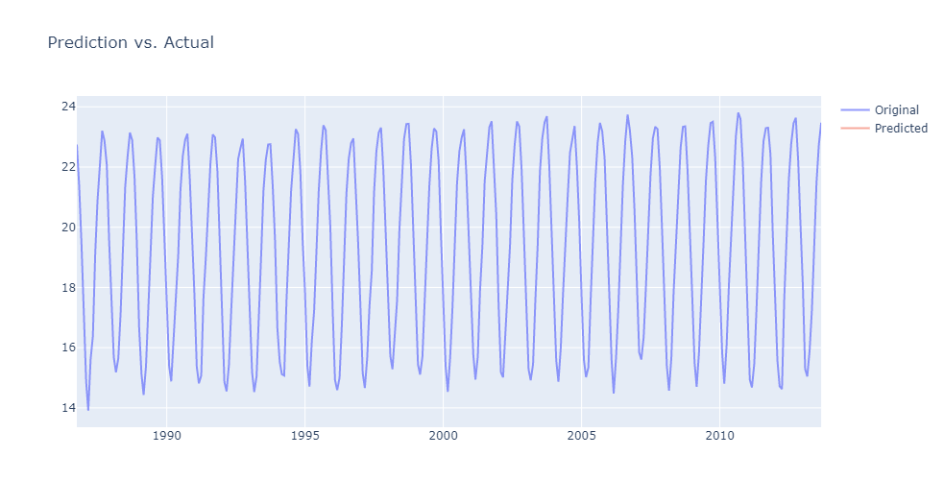

Region : US

